20MCA241-Data Science Lab B
- The following table shows the favourite sports of 300 students of a school.
- Create a bar chart with appropriate label and titles
- Set the color of bar as red and width .2
- Display the description of graph
Sports | Cricket | Football | Hockey | Badminton | Swimming | Tennis
No. of Students | 80 | 40 | 20 | 30 | 45 | 75

Ans

import matplotlib.pyplot as plt
import numpy as np
x = np.array(["cricket", "football", "hockey", "badminton","swimming","Tennis"])
y = np.array([80,40,20,30,45,75])
plt.bar(x,y, color="Red",width=2)
plt.show()

output:

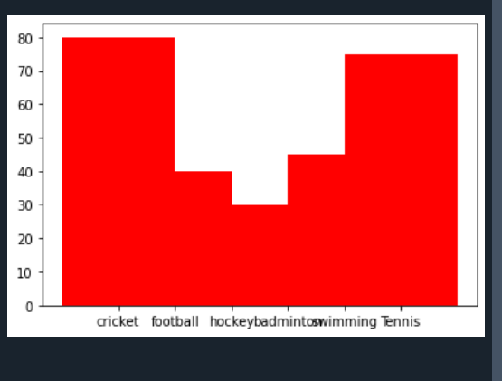
2.Write a Python program that accept a positive number and subtract from this number the sum of its digits and so on. Continues this operation until the number is positive

Ans

import numpy as np
def check_positive(n):
s = 0
numstr = str(n)
while (n > 0):
n -= sum([int(i) for i in list(numstr)])
numstr = list(str(n))
s+= 1
return s
print(check_positive(9))
print(check_positive(21))

Output

